Project Design Phase Solution Architecture

Date | 18 February 2026
Team ID | LTVIP2026TMIDS53672
Project Name | Exploratory Analysis of Rainfall Data in India for Agriculture
Maximum Marks | 4 Marks

Solution Architecture:
Solution architecture bridges the gap between agricultural business problems and technology solutions. Its goals include finding the best tech solution for existing problems , describing the software structure to stakeholders , and defining development phases and requirements.
+3

Example - Solution Architecture Diagram:

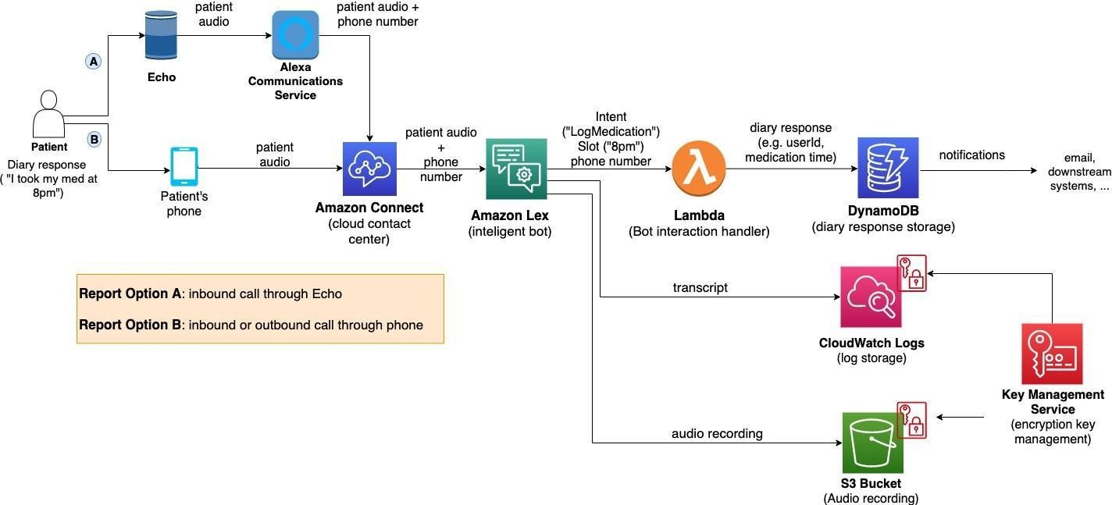
Figure 1: Architecture and data flow of the voice patient diary sample application
Reference: https://aws.amazon.com/blogs/industries/voice-applications-in-clinical-research- powered-by-ai-on-aws-part-1-architecture-and-design-considerations/

